 Nelamangala, India  +91 9902379659 gowdachandana22@gmail.com
CHANDNA.R
Java Developer, well versed with Visual Basic
Personal Statement
Hello, my name is Chandana R and I am an aspiring Web Apps Developer. I am pursuing final semester of Bachelor’s degree in computer application. My passion is to develop both web and mobile platforms including Android. I am also skilled in front-end development.
During my 5th Semester at college I have done work in visual basic for projects and I have begun to learn the working process of an organization.

Educational Qualification

Skills & Languages
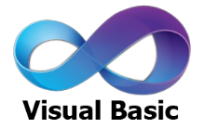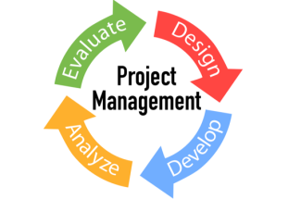

Tools


Projects
Title: Working of ATM

Front-End: Visual Basic 6.0 Back-End: MS-processer
Team Size: 4 Duration: One Month
Roles:
- Database Designer, Front-end Designer
Features:
PIN changing, withdrawal, credit, account management.
Description:
The purpose of developing this software is to show how ATM works. In the back-end we did all calculation work like withdrawal, credit, etc.

Other Achievements
- Have been a regular participant in college level seminars and debates
- Winner at District level Ko-koh and Throw ball competition
- Winner at college in Throw ball match

Personal Profile
Hobbies:

Music Puzzle Solving Dancing
Personal Details:
DOB: 30th Aug’96 Marital Status: Single Nationality: Indian
Contact Address: #6017/8, Sheshu Layout, Nelamangala, Bangalore – 562123

Declaration:
I hereby declare that the above information is true to the best of my knowledge and no misinterpretation is done.

Place: Nelamangala Chandana R

